The upper strip should be in deep blue color. Sampe is given below.

Contact & WhatsApp No - +91 9730567803
Email id – kaygudesatish10@gmail.com
My YouTube Channel link
https://youtube.com/@sap_satish?si=twn_Ei9gsZzo0DWG

My LinkedIn Profile link.
www.linkedin.com/in/satish-k-3ab082119
www.linkedin.com/in/kundan-kumar-kumar-consulting-a8172299
----------------------------------------------------------
My Logo.


------------------------------------------------------------------------------

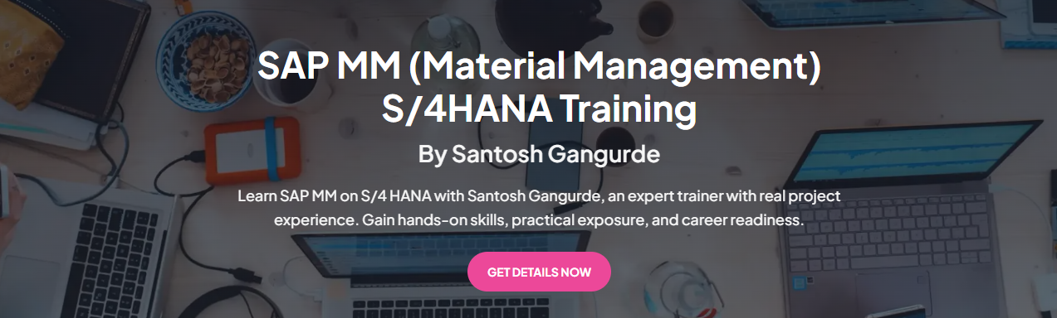
Kindly add below image and write the below content from left side.


Master SAP PP | MM on S/4HANA
(Real projects. Real scenarios. Real careers)
By Satish Kaygude | GS SAP Education

Master SAP PP and MM on S/4HANA with Satish Kaygude (GS SAP EDUCATION), a seasoned SAP consultant recognized for real-time project expertise and practical, business-driven training. Build hands-on skills, gain real-world exposure, and get fully prepared for interviews
-------------------------------------------------------------------
About Me
I am a Senior SAP Consultant and professional trainer with over 10 years of experience in SAP ECC and S/4HANA implementation, support, and rollout projects. I have consistently worked with business stakeholders to design, configure, and optimize SAP solutions, with a strong ability to convert complex business requirements into simple, scalable systems.
Alongside consulting, I am passionate about training and mentoring SAP aspirants and professionals. I have guided students, freshers, and experienced consultants with a focus on strong conceptual understanding, real-time business scenarios, configuration logic, and interview preparation. My training style is practical, structured, and aligned with industry needs—bridging the gap between theory and real project exposure.
I firmly believe in “Don’t memorize SAP—master it.
Currently, I continue to contribute to live SAP projects while developing high-quality training content to help professionals build confident and successful SAP careers.

--------------------------------------------------

Exp – 10+ years, Specialization – SAP PP/MM , Industry – IT
---------------------------------------------------
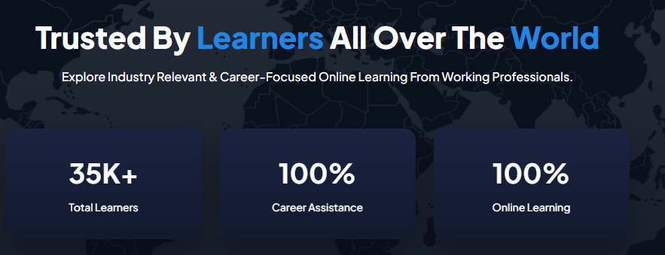
50 K+ , 100%, 100%
-------------------------------------------------

Training Features & Benefits
What you will get with this training program

- 80+ Hours of Complete SAP Training
Comprehensive SAP PP & MM coverage on S/4HANA, from fundamentals to advanced configurations with real project scenarios.
- Interview-Focused Questions & Answers
This tutorial includes real-time interview questions with detailed answers, designed around actual project and interview scenarios to help you confidently crack SAP interviews.
- SAP Errors & Solutions
One of the biggest challenges learners face while practicing SAP is encountering multiple functional errors at different stages. There’s no need to worry—this tutorial provides clear and practical solutions to the most commonly faced SAP errors.
Each issue is explained in a simple, step-by-step manner, helping you resolve errors quickly and continue practicing SAP smoothly and confidently—without unnecessary confusion or delays.
- Exclusive Job Portal
Get instant access to our exclusive job portal, where thousands of career opportunities await you. Connect directly with top companies actively hiring, and apply to roles that perfectly match your skills, experience, and career aspirations.
Take the next step toward your SAP career with confidence.
- Professional Resume Templates
Get interview-ready faster with professionally designed SAP resume templates. These templates are tailored for freshers and working professionals, helping you present your skills, project experience, and SAP expertise clearly and effectively.
Stand out to recruiters with a resume that speaks the SAP language.

Share your Bank Details where you want to credit your money

Account Holder Name: Radhika Pal
Bank Name: IDBI
Account Number:0072104000375139
IFSC Code: IBKL0000072
Branch Name:
Branch Address: Court Road, adjacent Hotel Raj Continental, Amritsar, Punjab 143001
PAN Card Number: HVLPP8232E
Contact Number:+91 90568 67157

